Challenge on AWS VPC
Use Case: Setting up Transit Gateway and VPC Endpoints for
a Multi-VPC Architecture
Scenario:
A large organization is migrating its on-premises infrastructure to the AWS cloud.
The organization's architecture involves multiple VPCs for different departments and applications, each requiring secure communication with centralized services and external resources.
The IT team needs to design and implement a scalable and efficient network architecture to accommodate the organization's growth and ensure robust connectivity between VPCs and external services.
Objectives:
- Design and deploy a scalable network architecture using AWS Transit Gateway to simplify network connectivity between multiple VPCs.
- Configure VPC endpoints to securely access AWS services without internet gateways or NAT gateways, ensuring data privacy and minimizing exposure to external threats.
Prerequisites:
• Require multiple VPCs
• Connect them using AWS Transit Gateway (TGW)
• Verify communication between VPCs
• VPC Endpoints
• Access AWS services privately without Internet Gateway or NAT Gateway

Architecture
AWS Region (Oregon)

+--------------------+
| Transit Gateway |
+---------+----------+
|
---------------------------------------
| | |
VPC-1 VPC-2 VPC-3

Public Private Private
Subnets Subnets Subnets

\ | /
\ | /
------ AWS Backbone -------------

|
VPC Endpoint
(S3)

Part 1 — Create Three VPCs

VPC-1
creating new pvc
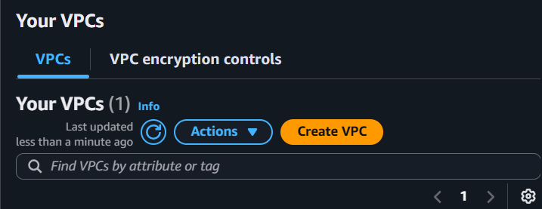
CIDR
10.0.0.0/16
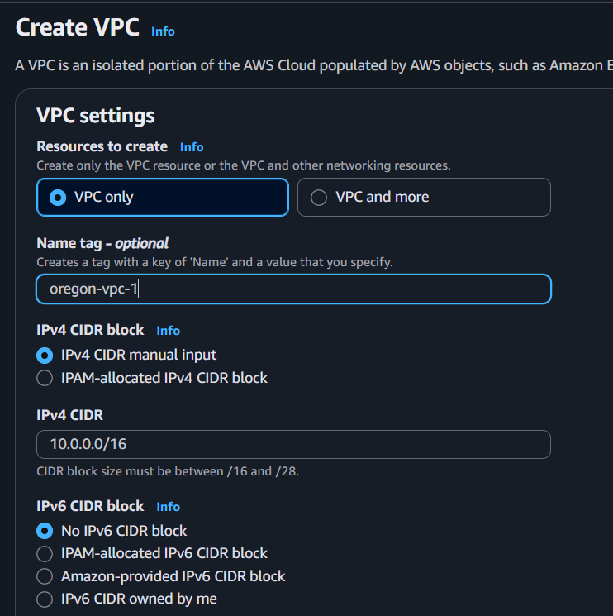
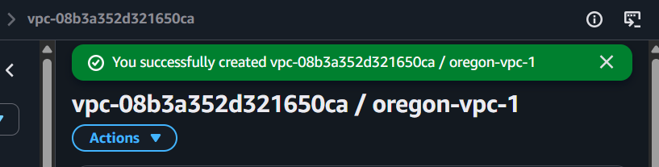
Subnets
Public-1
10.0.1.0/24
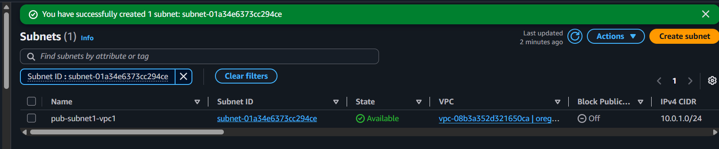

Private-1
10.0.2.0/24
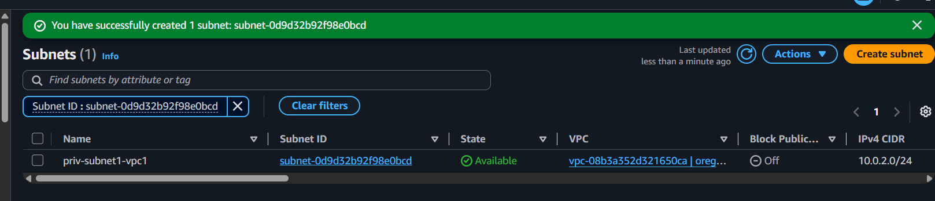

VPC-2
CIDR

10.1.0.0/16
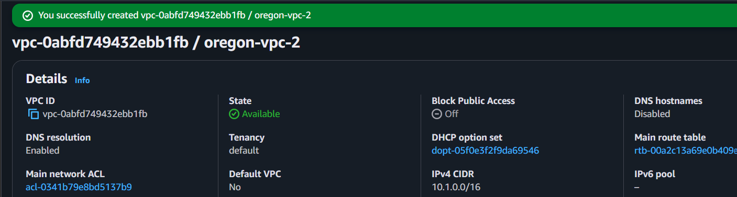

Subnets
Private-1

10.1.1.0/24
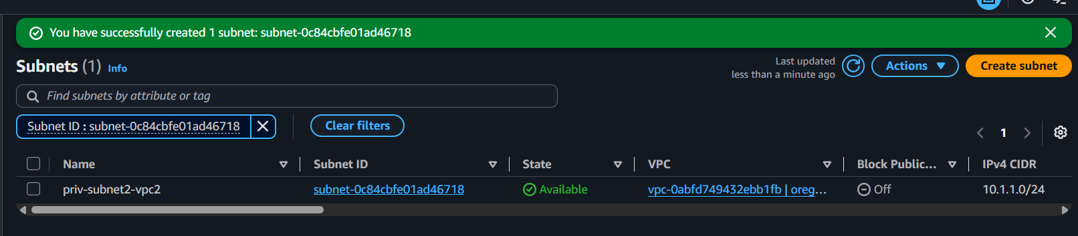

Private-2

10.1.2.0/24
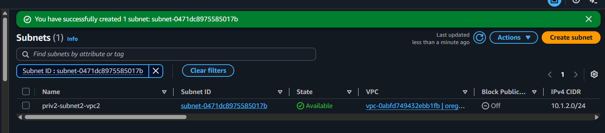

VPC-3
CIDR

10.2.0.0/16
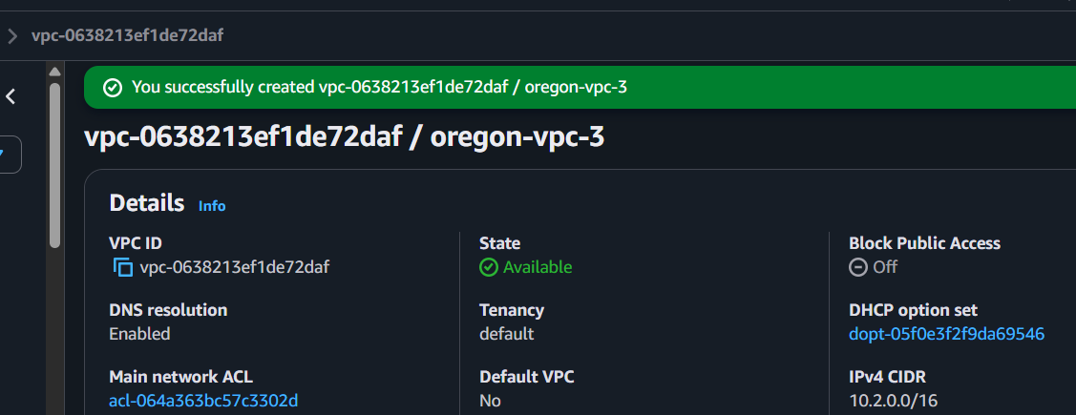
Subnets
Private-1

10.2.1.0/24
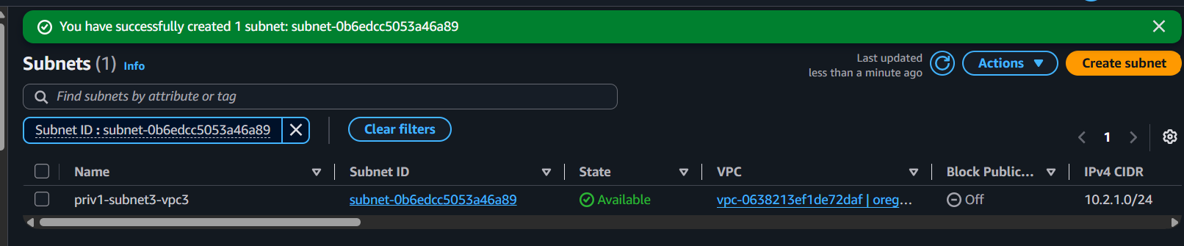

Private-2

10.2.2.0/24
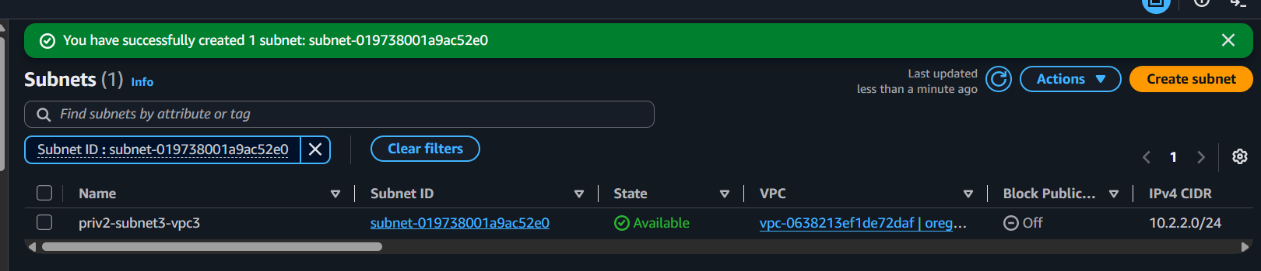

Enable
- DNS Resolution
- DNS Hostnames
for all VPCs.
For VPC-1
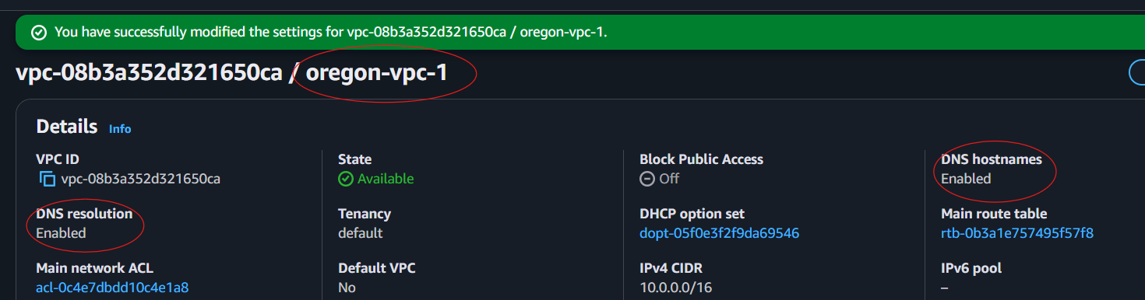
For VPC-2
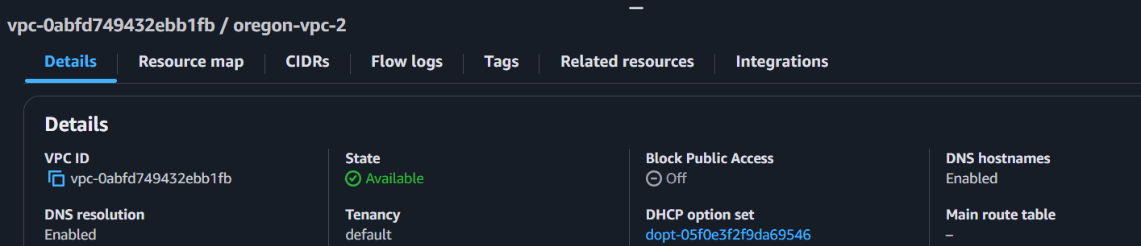
For VPC-3
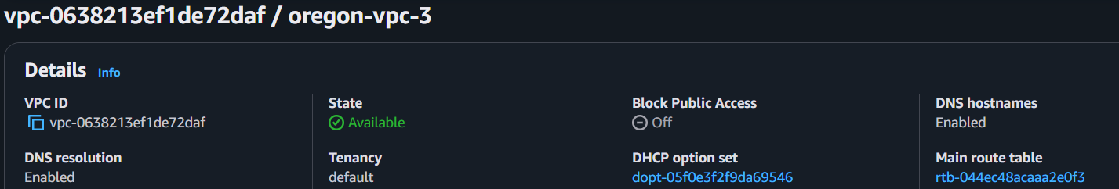

Part 2 — Internet Gateway
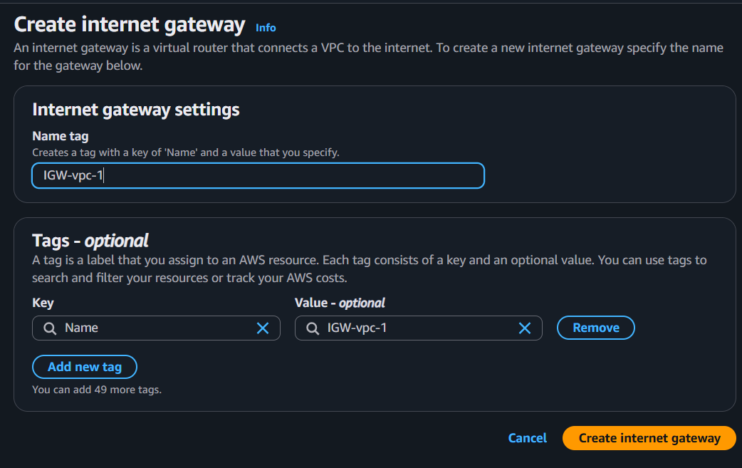
Attach Internet Gateway only to VPC-1 because VPC-2 and VPC-3 should remain private.
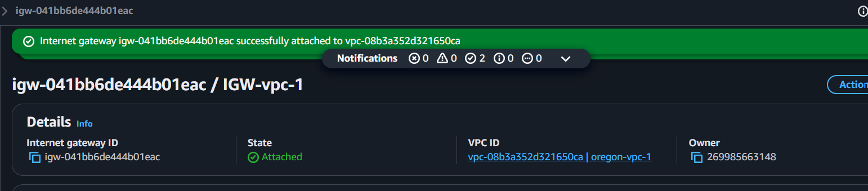

Part 3 — Route Tables

VPC-1 Public Route Table
Destination

10.0.0.0/16

Target

local

Destination

0.0.0.0/0

Target

Internet Gateway
Associate
Public subnet only
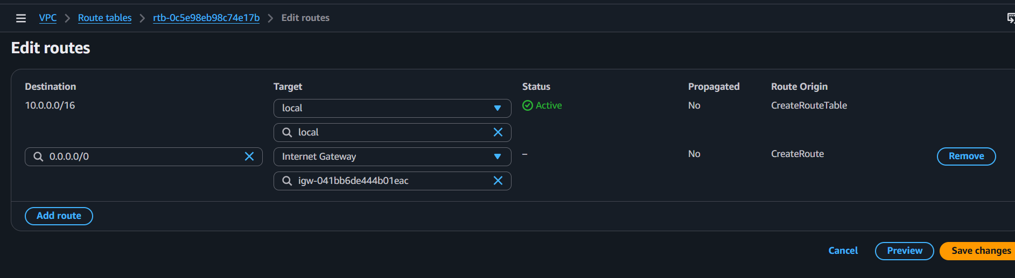
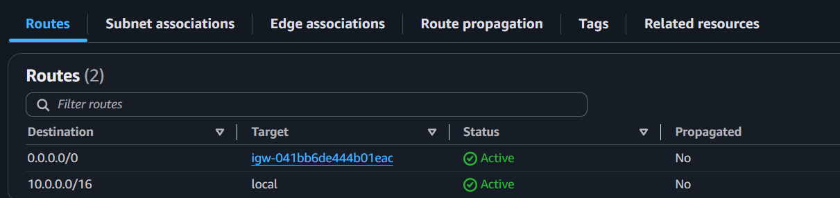

VPC-1 Private Route Table
10.0.0.0/16

local
Associate
Private subnet.

VPC-2
Private Route Table
10.1.0.0/16

local

VPC-3
10.2.0.0/16

local

Part 4 — Launch EC2 Instances
Launch one EC2 instance in each VPC.
Instance | VPC | Subnet
TGW-EC2-1 | VPC-1 | Public
TGW-EC2-2 | VPC-2 | Private
TGW-EC2-3 | VPC-3 | Private
Launching Instance 1
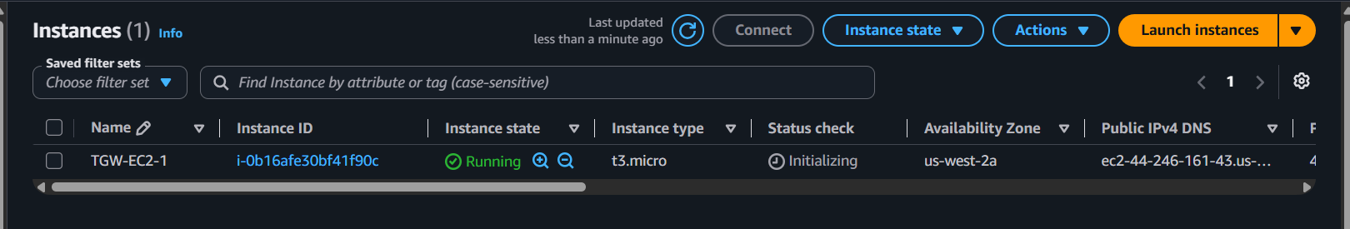
Security Group
SSH 22 Your IP
ICMP All 10.0.0.0/8
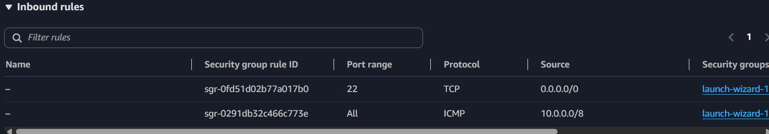
Launching Instance 2
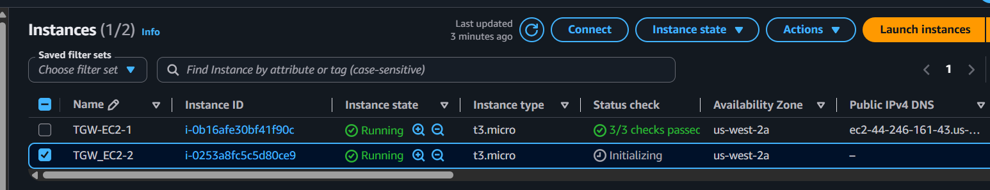
Security group
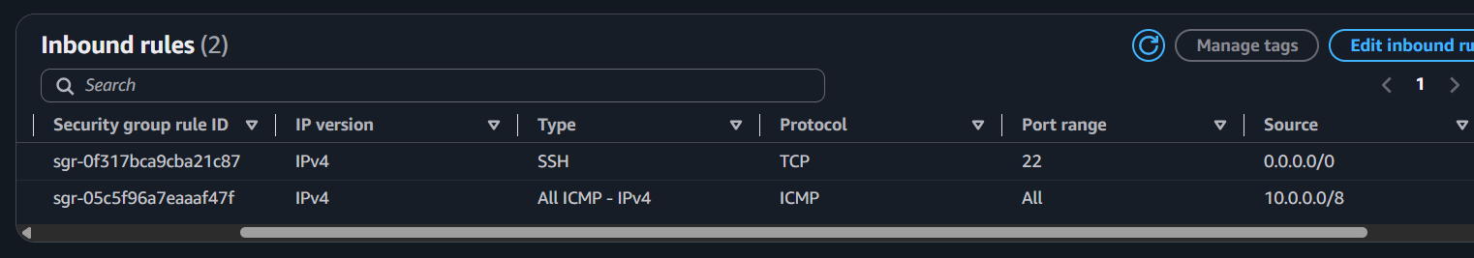
Launching Instance 3
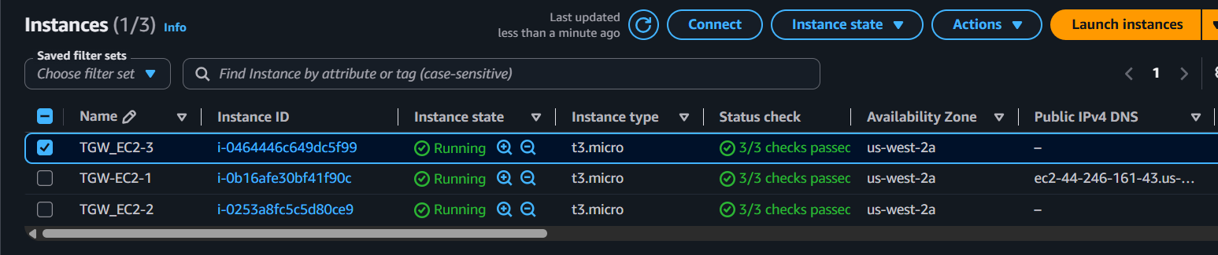
Security group
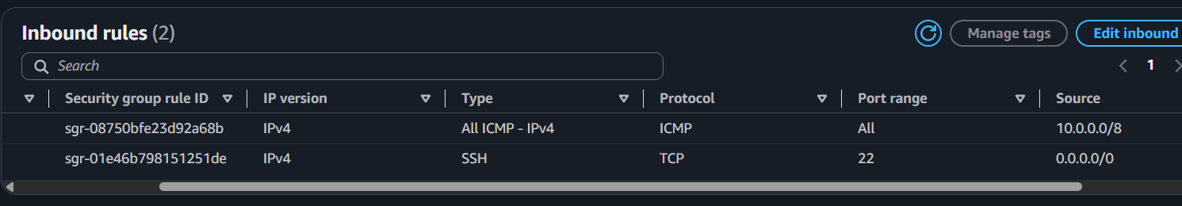

Part 5 — Create AWS Transit Gateway
Name
TGW-Oregon
Leave default settings and click on create transit gateway
Wait until status should be
Available
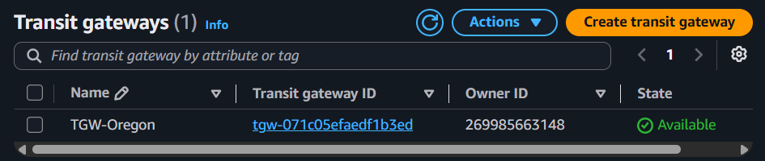

Part 6 — Create TGW Attachments
Create attachment for

Attachment 1
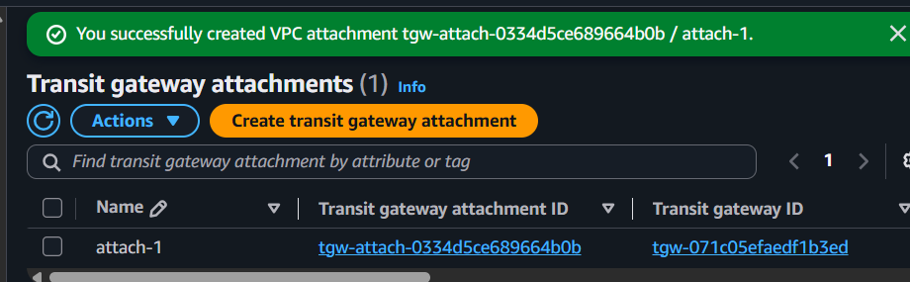

Attachment 2
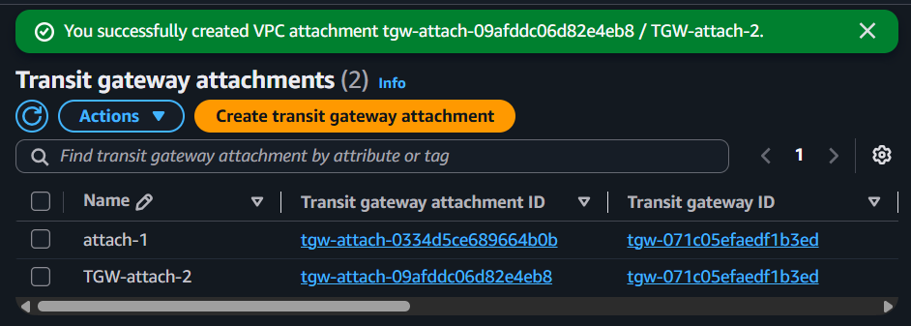

Attachment 3
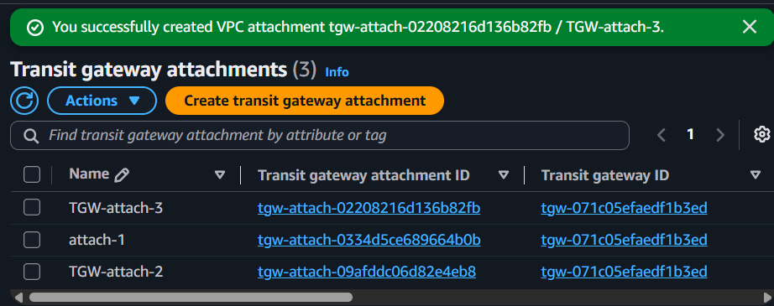
Wait until all attachments become
Available
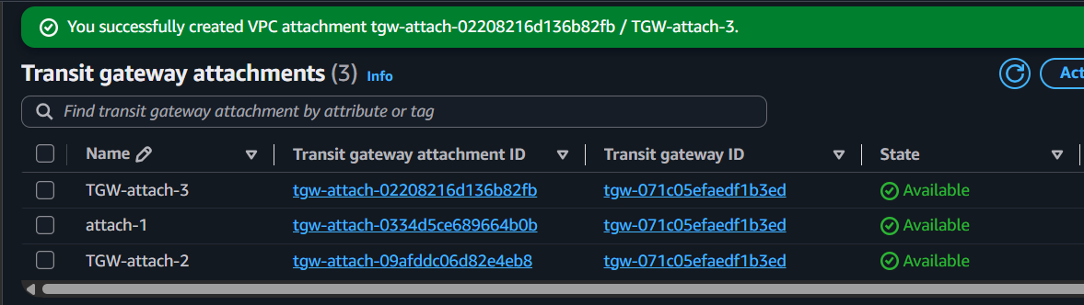

Part 7 — Update Route Tables
Now each VPC should know how to reach the others.

VPC-1 public Route Table
Add
10.1.0.0/16

Transit Gateway

10.2.0.0/16

Transit Gateway
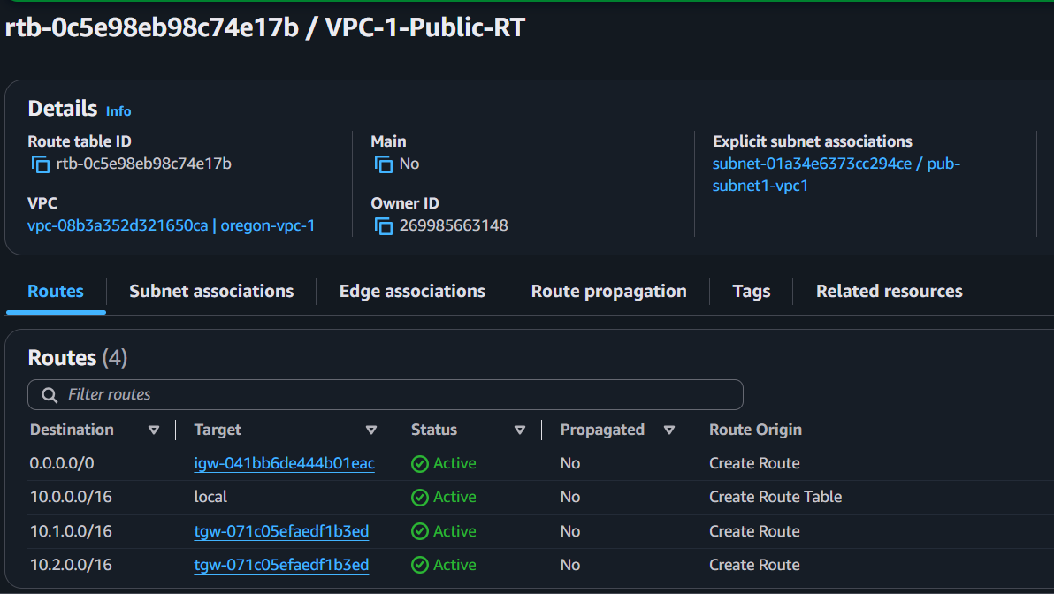
VPC-1 Private Route Table
Add the same routes:
Destination | Target
10.1.0.0/16 | Transit Gateway
10.2.0.0/16 | Transit Gateway
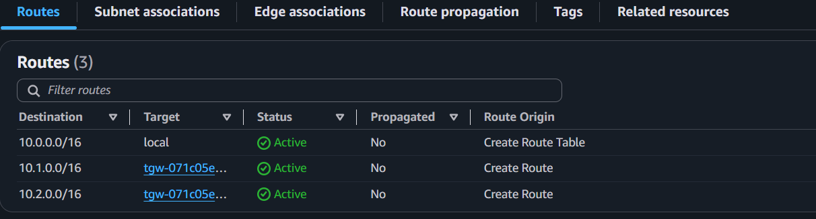

VPC-2 Route Table
10.0.0.0/16

Transit Gateway

10.2.0.0/16

Transit Gateway
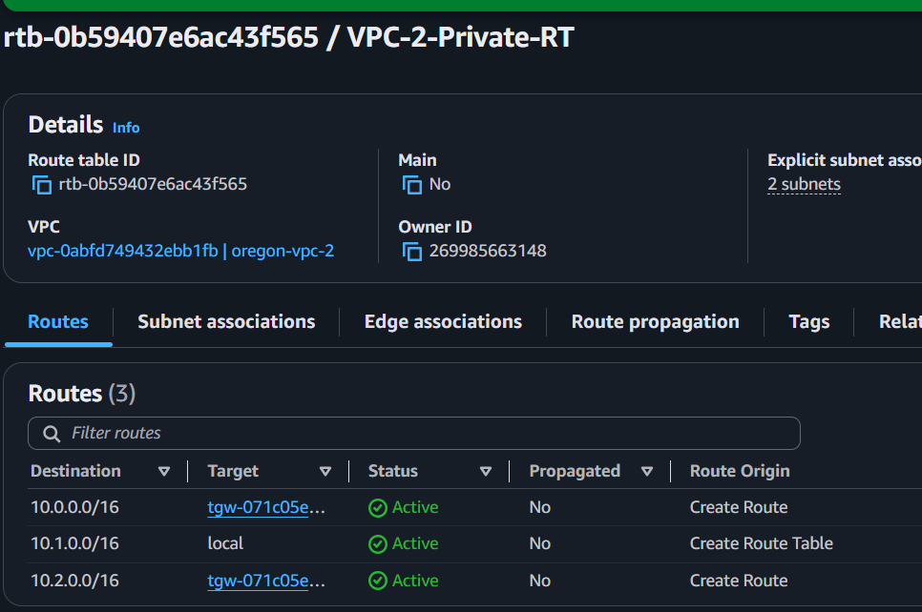

VPC-3 Route Table
10.0.0.0/16

Transit Gateway

10.1.0.0/16

Transit Gateway
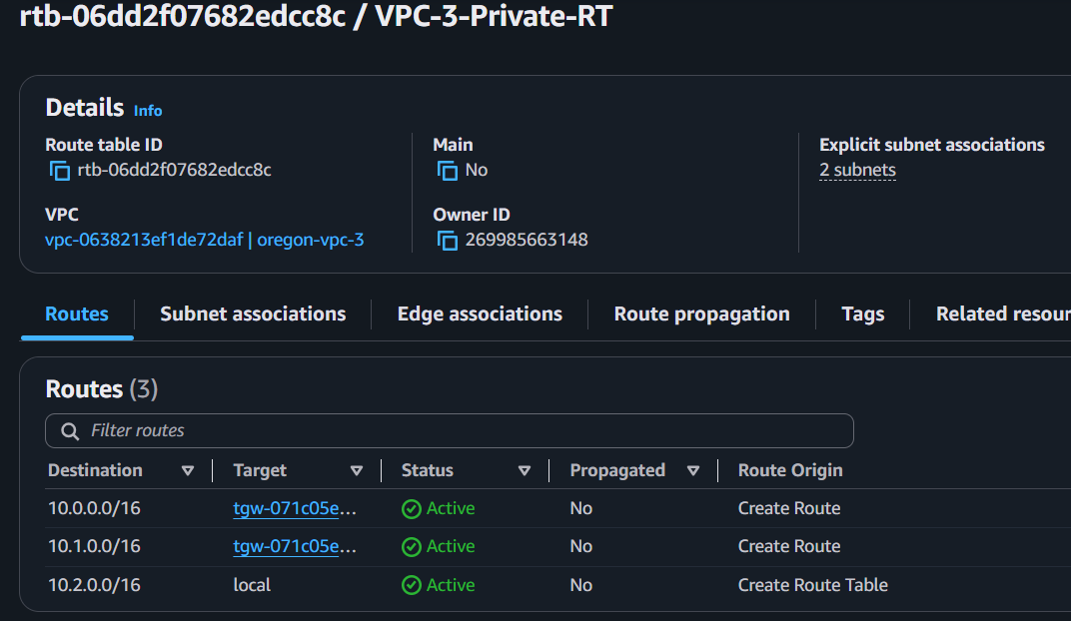

Part 8 — Test Connectivity
SSH into first instance TGW-EC2-1
4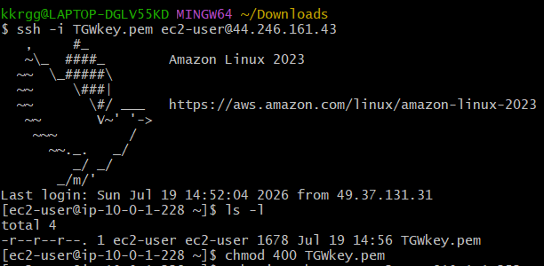
From there, SSH to the private servers using their private IPs.
Test the first private instance using private ip
Ping 10.1.1.252
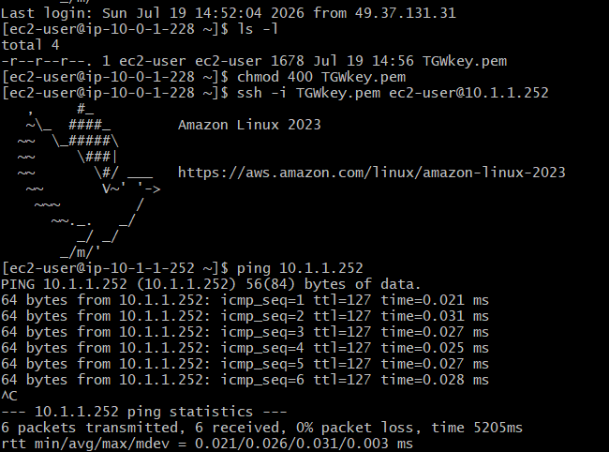
Test the second private instance using private ip
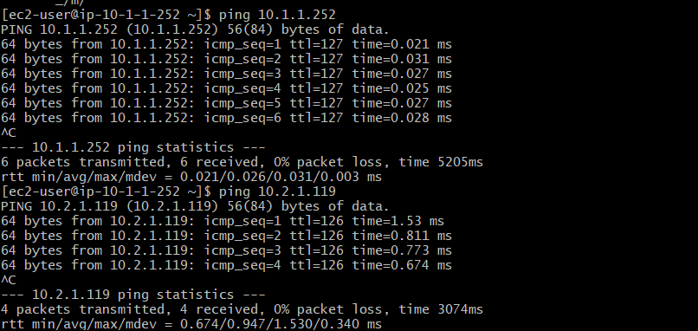
This Confirms that the Transit Gateway routing is working.

Part 9 — Create VPC Endpoint (S3)
Create endpoints
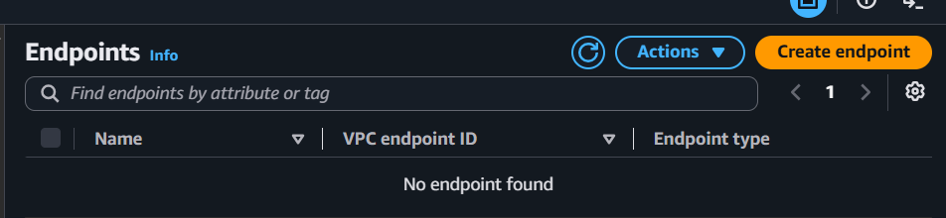Choose
AWS Services
Service
S3
Type
Gateway Endpoint
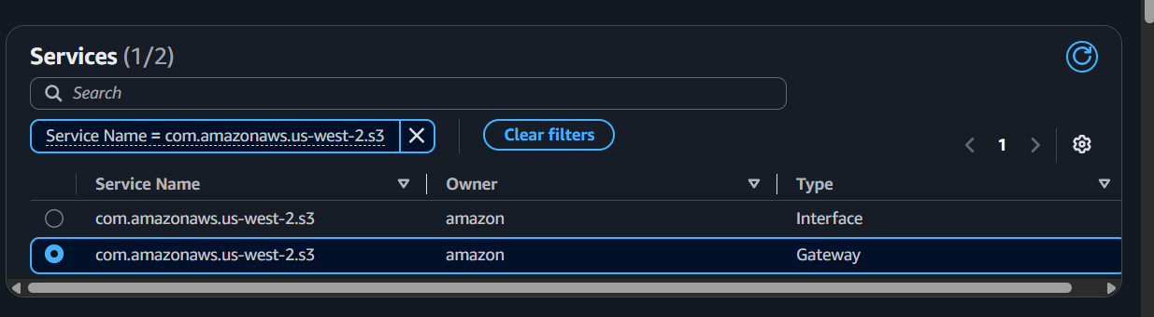
Select
VPC-2
Select the private route table.
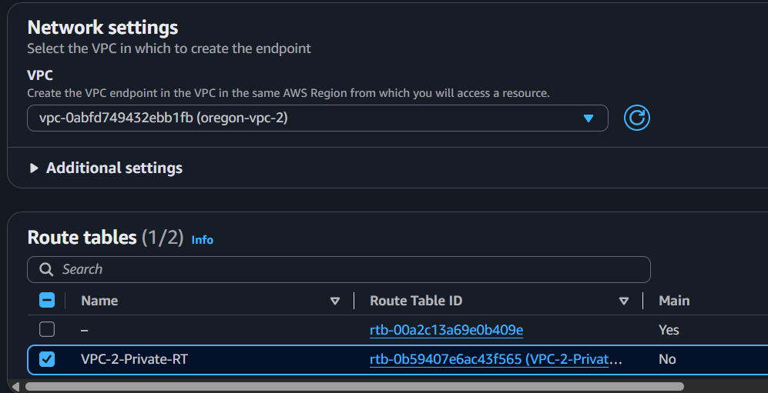
Create Endpoint.
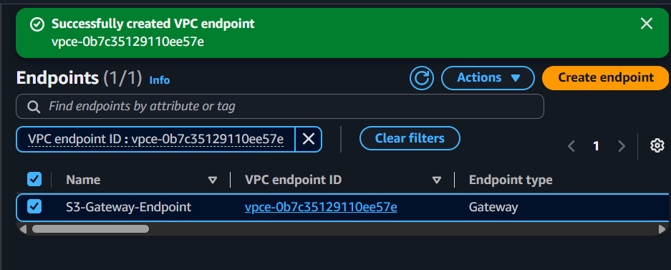

Now the route table will automatically contain an entry
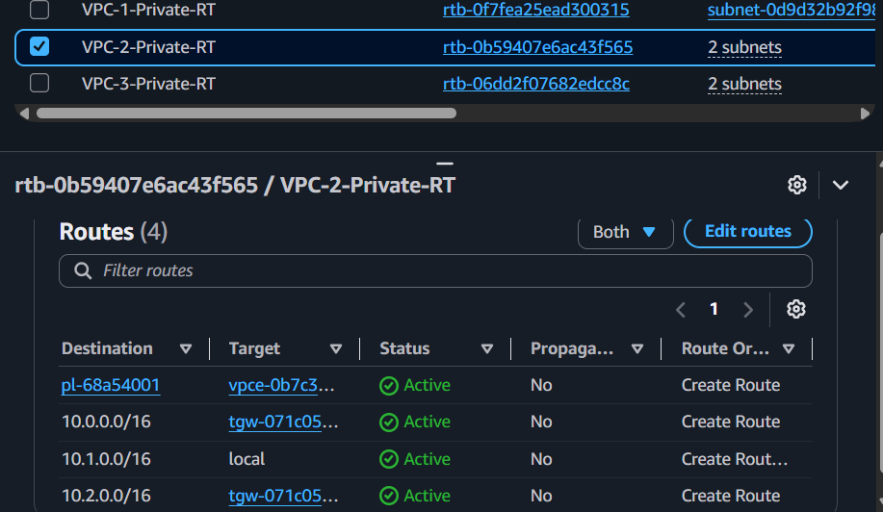
This allows instances in VPC-2 to access Amazon S3 over the AWS network without using an Internet Gateway or NAT Gateway.

Part 10 — Test S3 Endpoint
SSH into
DB-Server
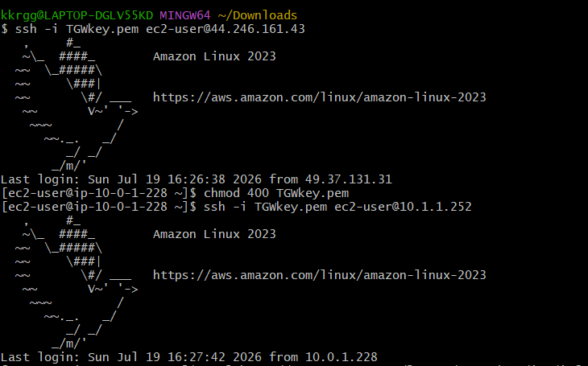
Install AWS CLI if required.
Run
aws s3 ls
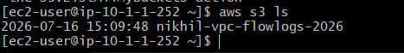
Attach an IAM role with S3 permissions to the EC2 instance. If the command succeeds without internet access, the Gateway Endpoint is working.

